**Name** : More Mayur Shankar

**Project Name**: Greenmart

**Frontend**: React .js

**Backend**: Node.js Exprees.js

**Database**: MongoDB

**Authentication**: JWT

**Date of Submission**:

**Project Description :**

**GreenMart** is a full-stack web application that allows users to **order groceries online** and have them delivered by assigned delivery staff. The project is built using the **MERN Stack** (MongoDB, Express.js, React.js, Node.js) with **role-based login** for Admin, Users.

### How it works:

* **Users** can:
  + Register/Login
  + Browse products
  + Add to cart
  + Place orders
  + Track their order status
* **Admin** can:
  + Manage products (add/edit/delete)
  + View all orders
  + Assign orders to delivery staff
  + Track monthly reports (orders, revenue, stock)

### **Key Features**:

* + Role-based authentication (User, Admin, )
  + Stock management (auto-reduce after order)
  + Email confirmation for orders
  + Responsive Bootstrap UI
  + Monthly sales and product insights

Project Images:

Home Page:

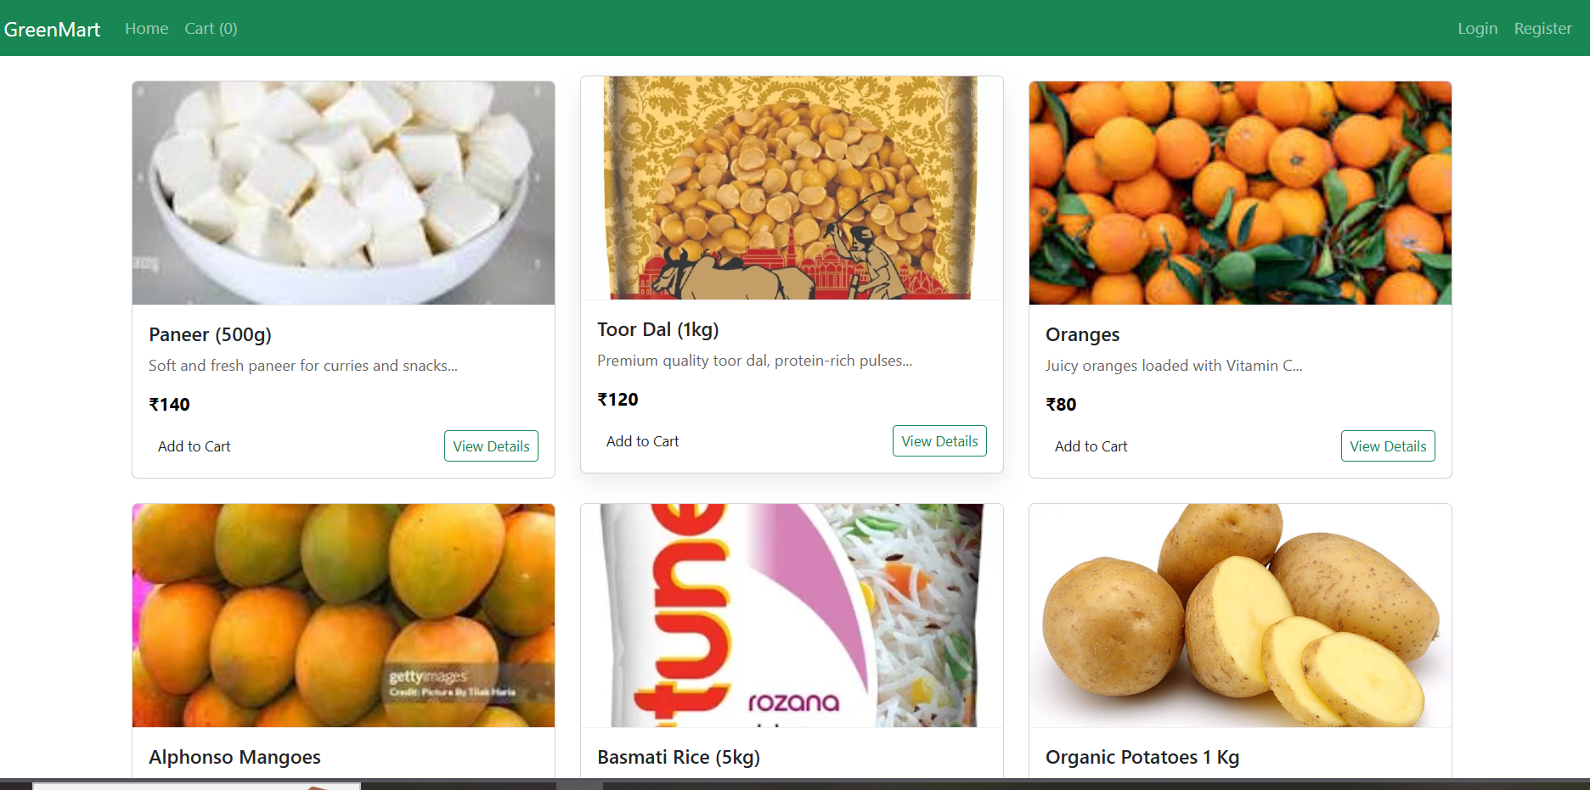

Register Page:

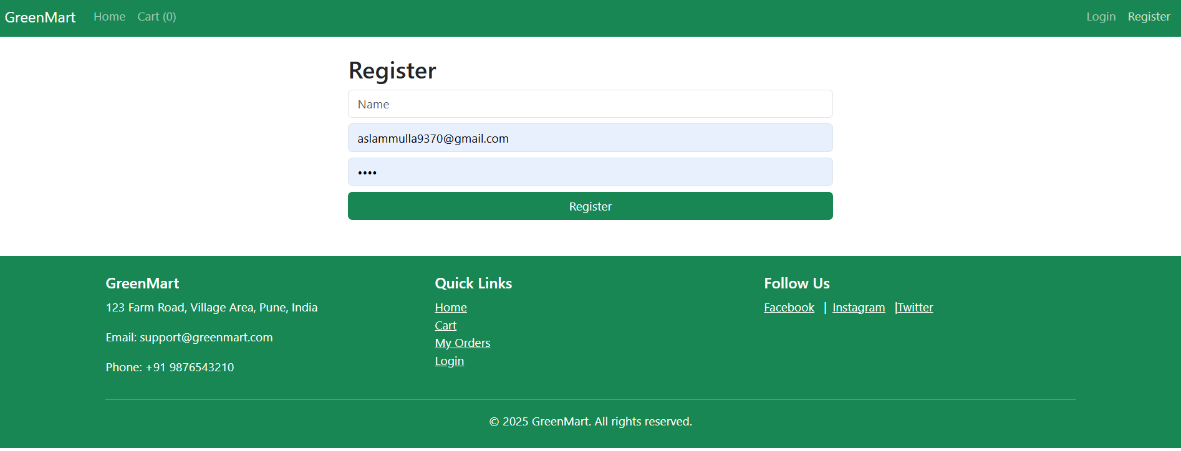

Login page:

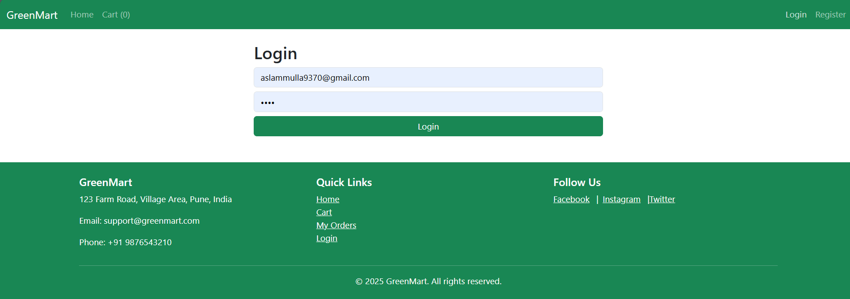

Product Details Page:

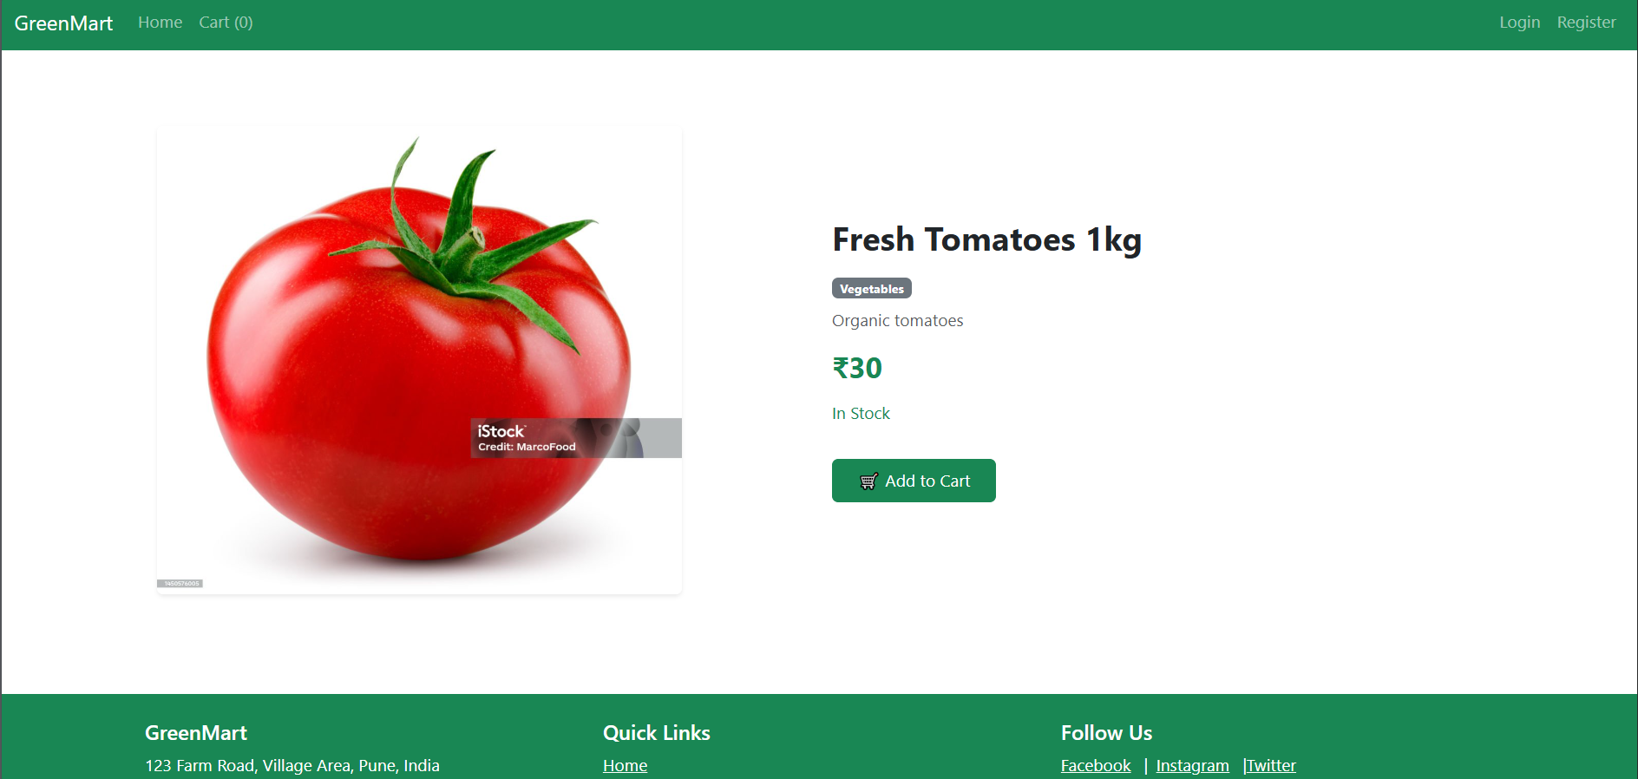

User Dashbord:

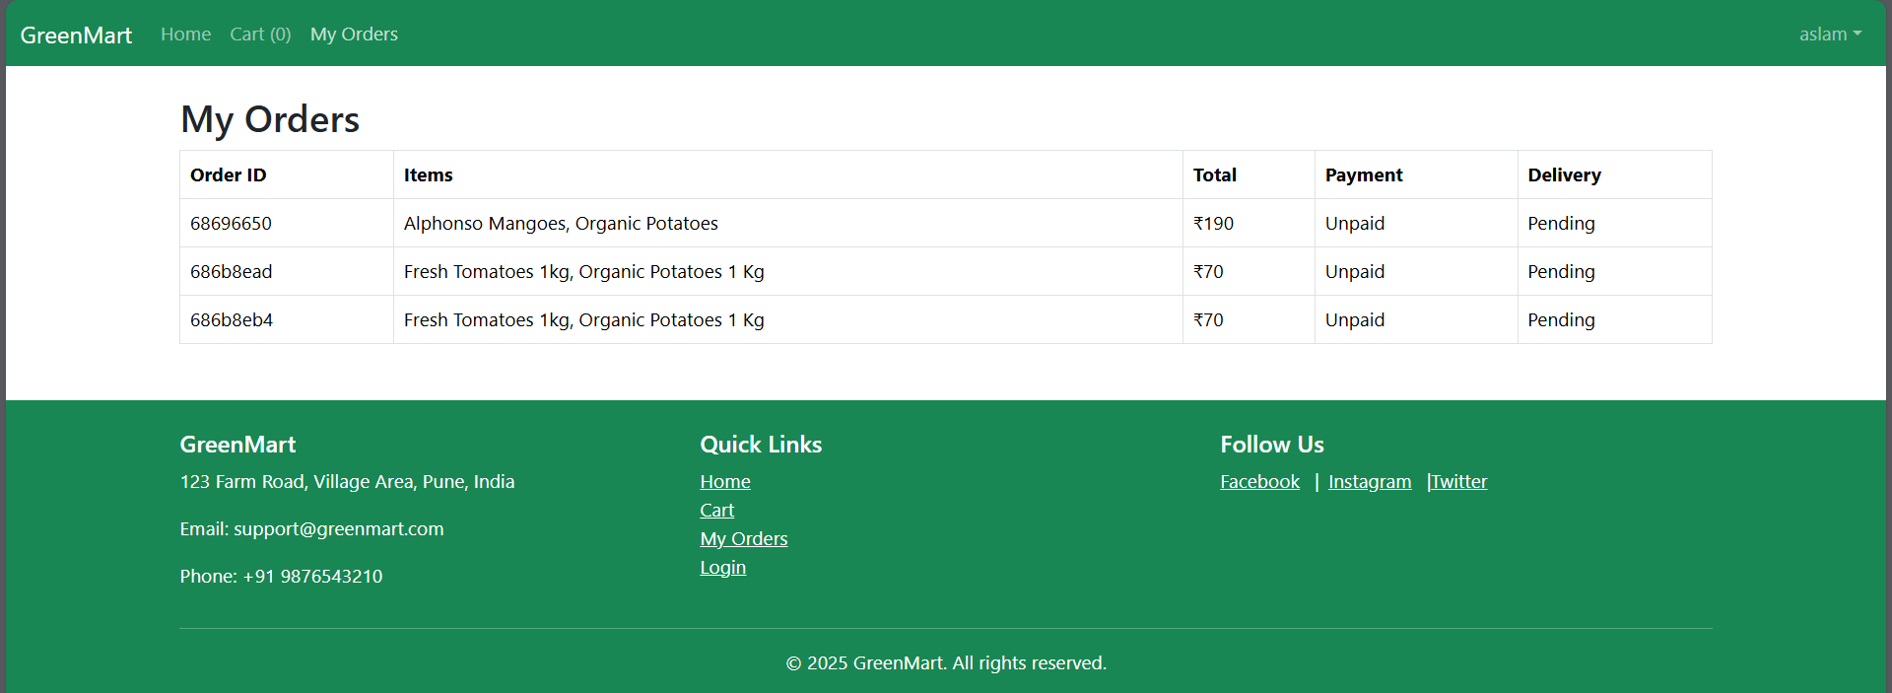

Cart page:

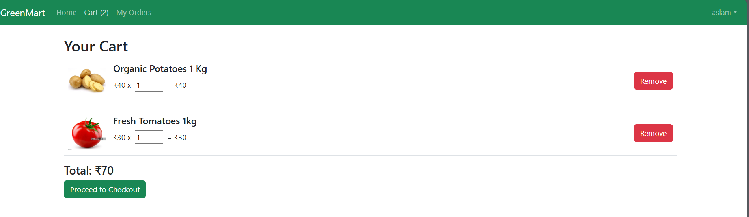

Checkout:

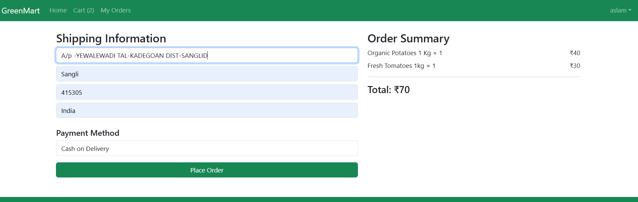

Order Confirmation Mail :

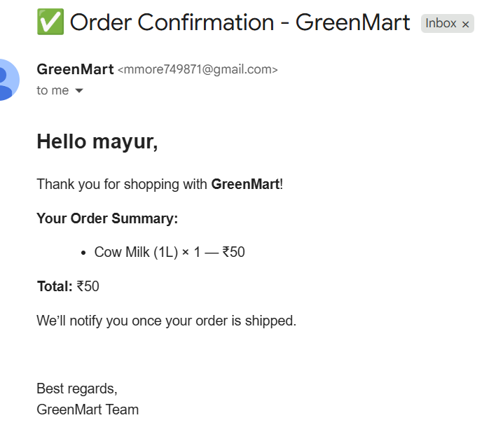

Admin DashBorad:

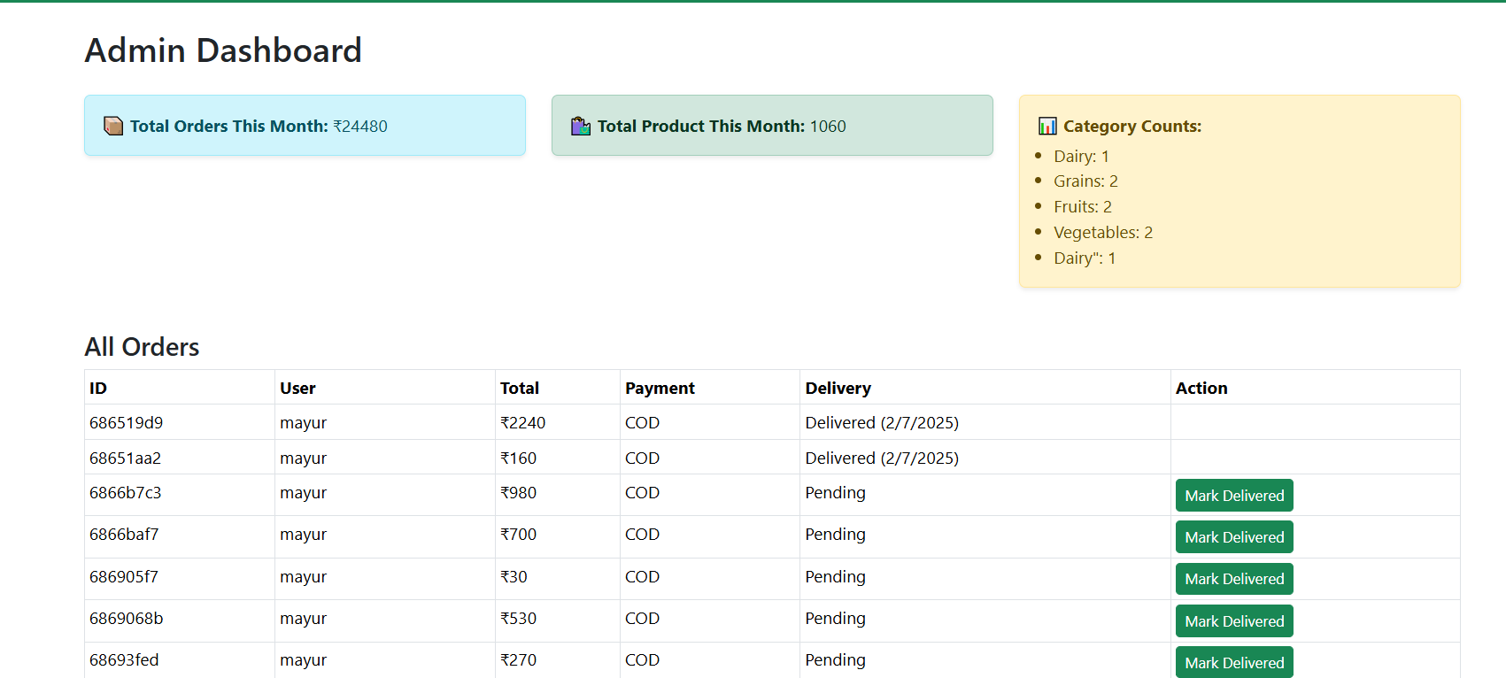

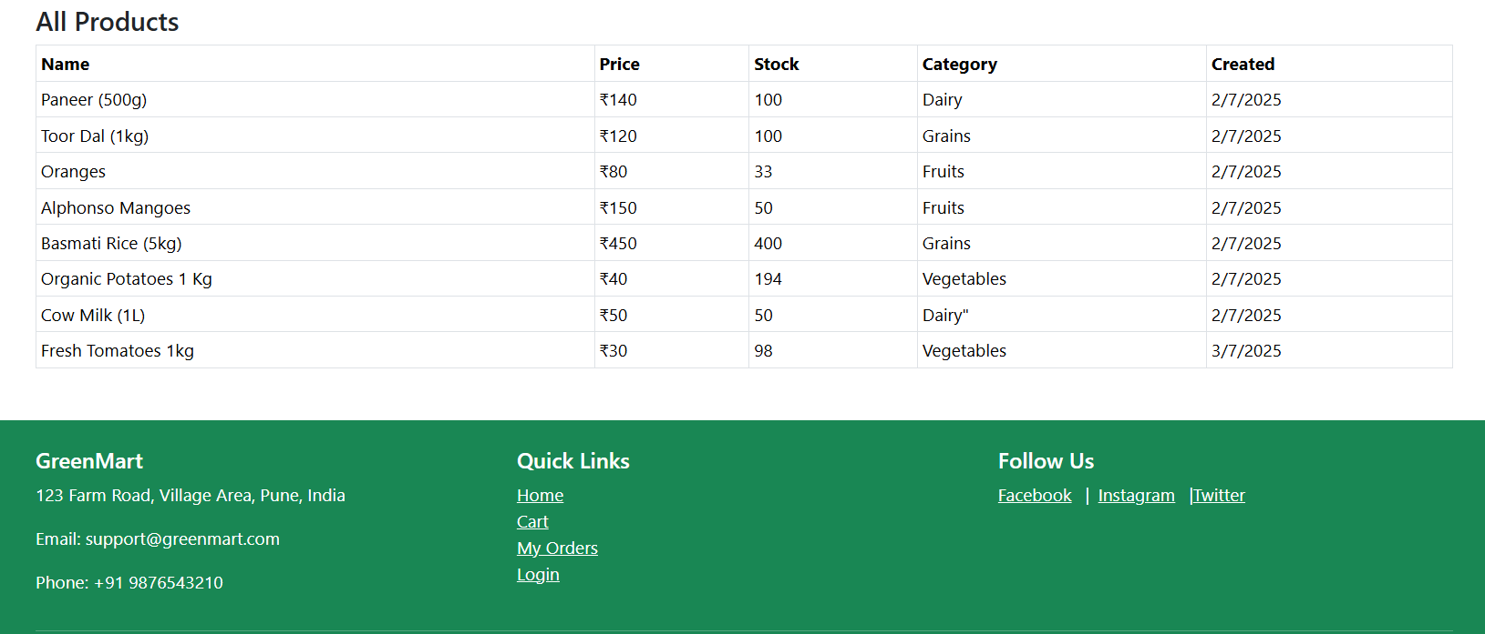

Admin Manage Products:

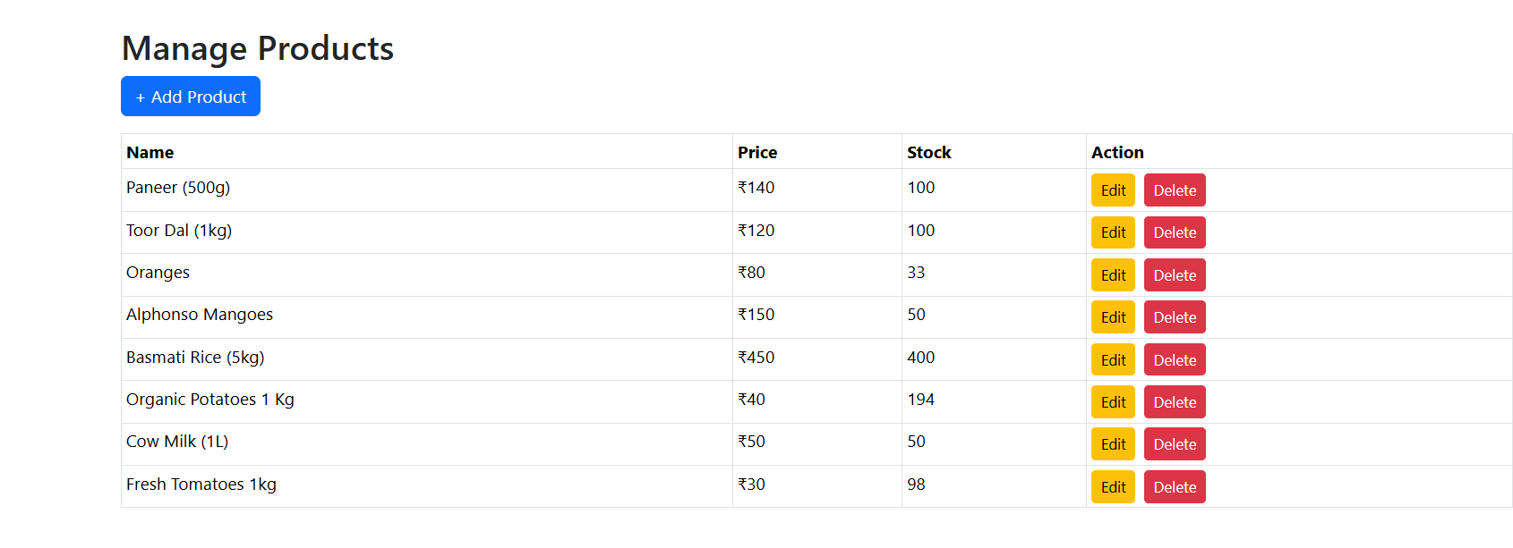

Admin Add Product:

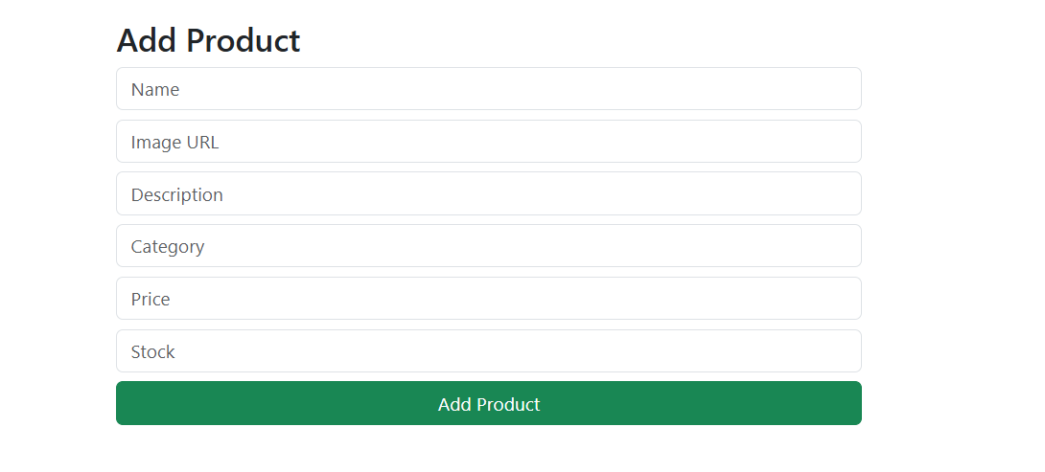

Admin Edit Product:

